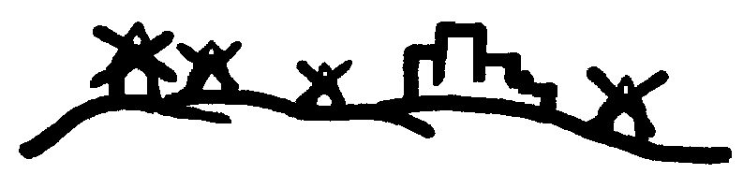


TRABAJO ESPAD
INGLÉS (2021/22)
MÓDULO 4

APELLIDOS Y NOMBRE:
LOCALIDAD:

INSTRUCCIONES:
FECHA TOPE DE ENTREGA: EL DÍA 25 DE MAYO DE 2022.

LOS TRABAJOS SERÁN ENTREGADOS AL PROFESOR(A) DE INGLÉS O EN LA SECRETARÍA DEL CEPA.

LOS TRABAJOS DEBEN SER ORIGINALES, ESTAR COMPLETOS, NO ESTAR NI COPIADOS NI FOTOCOPIADOS, MANUSCRITOS A BOLÍGRAFO NEGRO O AZUL, CON TODAS LAS HOJAS GRAPADAS Y SER DEL MÓDULO O MÓDULOS EN LOS QUE SE ESTÉ MATRICULADO/A.

1. Fill in the gaps with the future of “will”. Completa con futuro de “will”. (4 p)
- They think I……………………………….…(forget) the date , but I won´t do.
- Perhaps I ……………………………………….(find) my keys at work.
- Maybe I ____________________ (travel) around Europe this summer.
- I think that my brother _________________ (not/study) Medicine.

2. Fill in the gaps with “BE GOING TO”. Completa con BE GOING TO. (5 p)
- I ________________ (visit) my sister next month.
- I've bought a new book. Tonight I _________________ stay at home and start reading it.
- Look at the boy on the roof! He _____________________ (fall down).
- Look at those clouds!! It _____________________ (rain).
- My brother ________________ (study) Education at university.

3. Complete the next sentences with WHO, WHOSE, WHAT o WHICH. Completa las siguientes oraciones con WHO, WHOSE, WHAT o WHICH. (5 p)
- ‘ _________________ time is it?’ ‘It’s half past three.’
- ‘_________________ jacket is this?’ ‘It’s mine.’
- ‘I’ve got chocolate ice cream and vanilla ice cream, _________________ do you prefer?’
- ‘_________________ is that man with your wife?’ ‘It’s her boss.’
- ‘_________________ did you say?’ ‘I didn’t say anything.’

4. Complete using HOW MUCH or HOW MANY. Completa utilizando HOW MUCH o HOW MANY. (6 p)
- ____________________ birds are there? There are two birds.
- ____________________ money is there? There are three thousand dollars.
- ____________________ dolphins are there? There are two dolphins.
- ____________________ pencils are there? There are thirteen pencils
- ____________________ books are there? There are three books.
- ____________________ milk is there? There are four litres of milk.

5. Fill in the gaps with the appropriate interrogative pronoun. Pay attention to the underlined words. Completa en los huecos con el pronombre interrogativo adecuado. Presta atención a las palabras subrayadas. (8 p)
- …………………..are you from? I´m from Madrid.
- …………………………….friends have you got? I´ve got five friends.
- ………………………….is that jacket? It´s Mary´s .
- ……………………….is your party? It is next weekend.
- .........................dish do you prefer, meat or fish?
- ……………………………is your boyfriend? He is in Boston.
- …………………………..do you eat fruit? I eat fruit twice a day.
- ………………………are you smoking? Because I am very nervous.

6. Fill in all the gaps using the correct modal verb. Completa con el verbo modal adecuado. (7 p)
- She looks pretty sick - I think she _____________ go to a doctor. (can / should)
- You've been driving all day - You _____________ be exhausted! (must / should)
- Hey I'm lost - _____________ you help me? (Should / Can)
- You have such a beautiful voice - You _____________ sing for us! (should / can)
- I know he speaks five languages, but _____________ he speak Arabic? (should / can)
- That looks very expensive. It vhave cost a fortune! (must / should)
- I'm on my way. I _____________ be there in about 10 minutes. (can / should)

7. Complete with the modal verb which fits the best in the gaps both in English and in Spanish. Completa con el verbo modal que mejor encaja en los huecos. (5 p)
- The students can / must / mustn’t hurry. They’re late! (Los estudiantes ………..darse prisa. Llegan tarde).
- I should / mustn’t / shouldn’t stop drinking so much alcohol. It’s bad for my health.(Yo…….dejar de beber tanto alcohol. Es malo para mi salud).
- Caroline may / shouldn’t / may not drive so fast. It’s very dangerous! (Caroline…….conducir tan rápido. Es muy peligroso).
- Can / Must / Should you tell me where’s the park, please? (¿………..decirme dónde está el parque, por favor?)
- I must / mustn’t / can have a shower tonight. I’m really tired! (Yo………………..darme una ducha esta noche. Estoy realmente cansada).

8. Fill in the gaps with one of the connectors from below in bold. Completa en los huecos con uno de los conectores de debajo en negrita. (6 p)
- ……………………….I had breakfast. ……………………I had a shower. ………………………….the shower I combed my hair and ………………………I went to work.
Then First finally After
- First, give him a ring. Second, take the car out from the garage………………..fetch my dog from the vet and……………………………go back home.
Finally Third

9. Complete with the correct form of the verb in brackets using the past simple. Completa con el pasado simple. (6 p)
BUY GO SEND LOSE TAKE MEET

- Helen __________________ a postcard from Ibiza to her parents.
- He __________________ a new pair of shoes at my mum’s shop.
- I __________________ to London for the weekend.
- My grandfather __________________ the bus to go to the football match. e)
- We __________________ some friends at a fancy restaurant.
- I haven’t got my credit card now because I __________________ it when I was on holiday.

10. Fill in the gaps with the verb in brackets in the PRESENT perfect. Completa con el verbo del paréntesis en presente perfecto. (4 p)

- Andy …………………………… his sister's bike. (not/repair)
- ……..… you……………… a knife in the kitchen? (drop)
- I………………..…. a new laptop. (buy)
- ………………..Toby…………………. his blue pen yet? (to find)

11. Fill in the gaps with the verb in brackets in the PAST perfect. Completa con el verbo del paréntesis en pasado perfecto. (4 p)
- They……………………………………….(redecorate) the whole house.
- …………………………you …………………………(notice) the fault on the CD player?
- I ……………………………………………….(not/ write) the email yet.
- We ………………………………………..(forget) to come to the meeting.

12. Complete these type 1 conditional sentences with the verb in brackets in the correct form. (6 p)
- If you………………………………(not/sure), ………………………………….(not/ do) it.
- ………………………Joanne……………………….(help) us if we ………………….(ask) her?
- He……………………………………(get in trouble) if he ………………………(keep) doing that.

13. Complete these type 2 conditional sentences with the verb in brackets in the correct form. (6 p)
- If I……………………….. (meet) Richard, I …………………………. (tell) him about our new office.
- If the steak……………….. (not be) so hot, we ……………………………. (eat) it.
- What……………………… (you/do) if it ……………… (rain)?

14. READING: Read the text and answer the questions. (Lee el texto y contesta a las preguntas). (8 p)

MARTIN’S DAY

Martin had a terrible day yesterday. It was the day of his vacation to Spain but it was a nightmare. He left the house at 10 o'clock in the morning and caught a taxi to the airport.
Martin went to the check-in with his luggage. When the man who worked for the airline asked for his passport, Martin became very upset. Where was his passport? Martin realized he didn't have his passport with him. What a disaster!
He jumped back into the taxi and told the driver to take him home. The driver drove quickly and Martin arrived back at his house in twenty minutes.
He ran into the house and went into his bedroom. He found his passport on the bedside table and left the house again. But the taxi wasn't there! Where was the taxi!
Martin jumped up and down angrily. "I don't believe it. The taxi left!" he shouted. He ran down the street and looked for another taxi.
After a few minutes, Martin found another taxi and told the driver to take him to the airport as quickly as possible. The traffic on the roads was very bad and, unfortunately, Martin's taxi arrived at the airport late. His plane left for Spain at 11.30 and Martin missed it. He was very sad and went to speak to the airline. They promised to get him a seat on an evening flight and Martin went home on another taxi to wait.

- Where was Martin going on holiday?

- What time did he leave the house?

- How did he get to the airport?

- When did he realize that he didn't have his passport?

- Where was the passport?

- What did Martin discover when he went back outside?

- How did Martin get to the airport the second time?

- Why did Martin go home?

15. LISTENING: Listen to the conversation and choose the right option (TRUE OR FALSE). Elige la opción correcta. (6 p)

A GOOD NIGHT’S SLEEP

1. The guest in the studio is a teacher. T / F
2. Some people can sleep well with a television on. T / F
3. It is bad to think a lot before going to bed. T / F
4. It is good to play video games before bed. T / F
5. It is good to turn your mobile off when you go to sleep. T / F
6. It is bad to play loud music while you sleep. T / F

16. WRITING. Fill in the following curriculum vitae with your personal details. Completa los apartados del siguiente curriculum con tus datos en inglés. (14 p)

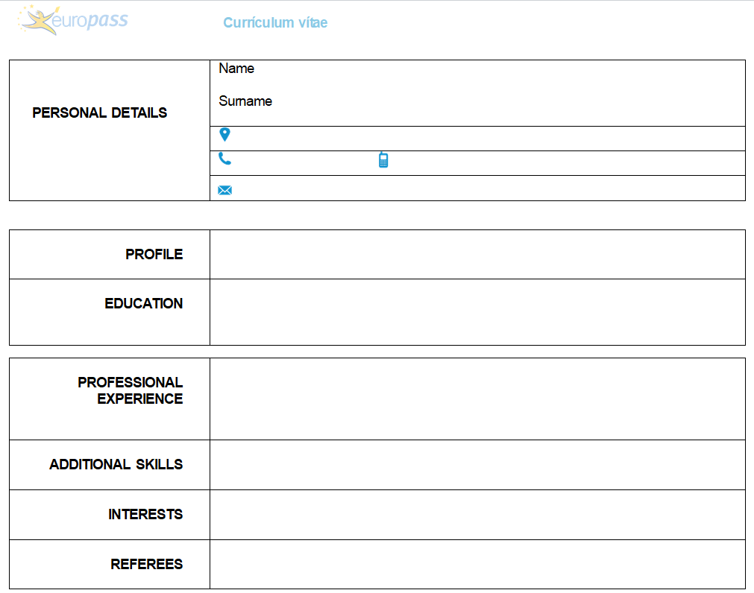

TOTAL MARK:___/100

